-- Hospital Data Analysis using SQL--

- Total Number Of Patients

Write an SQL query to find the total number of patients across all hospitals.

Answer:
Select Sum(Patients_count) As Total_Patients
from Hospital_records;
Output:



2. Average Number of Doctors per Hospital

Retrieve the average count of doctors available in each hospital.

Answer:
Select hospital_name,
AVG(doctors_count) As Total_Doctos
From hospital_records
Group By hospital_name;
Output:



3. Top 3 Departments with the Highest Number of Patients

Find the top 3 hospital departments that have the highest number of patients.

Answer:
Select department,
sum(patients_count) As Highest_number_of_patients
from hospital_records
Group BY department
Order by Highest_number_of_patients
Desc limit 3;
Output:



4. Hospital with the Maximum Medical Expenses

Identify the hospital that recorded the highest medical expenses.

Answer:
Select hospital_name,
MAX(medical_expenses) AS MAX_medical_expenses
From hospital_records
Group by hospital_name
order by MAX_medical_expenses DESC limit 1;
Output:



5. Daily Average Medical Expenses

Calculate the average medical expenses per day for each hospital.

Answer:
Select hospital_name,admission_date,
Avg(medical_expenses) AS avg_daily_expenses
From hospital_records
Group by hospital_name,admission_date
order by admission_date;
Output:

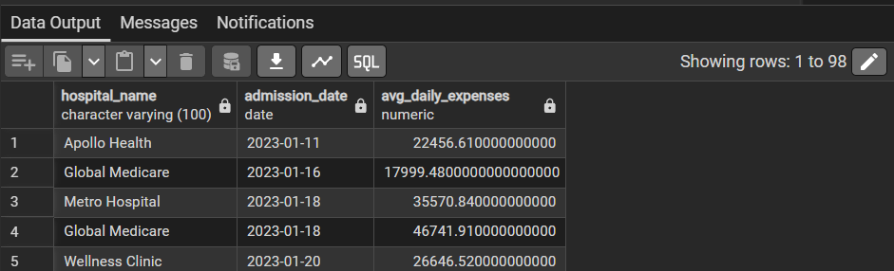

6. Longest Hospital Stay

Find the patient with the longest stay by calculating the difference
between Discharge Date and Admission Date.

Answer:
Select hospital_name,
(discharge_date - admission_date) AS stay_days
From hospital_records
Order by stay_days
Desc limit 1;
Output:



7. Total Patients Treated Per City

Count the total number of patients treated in each city.

Answer:
SELECT location,
SUM(patients_count) AS total_patients
FROM hospital_records
GROUP BY location;
Output:



8. Average Length of Stay Per Department

Calculate the average number of days patients spend in each
department.

Answer:
SELECT department,
AVG(discharge_date - admission_date) AS avg_stay_days
FROM hospital_records
GROUP BY department;
Output:
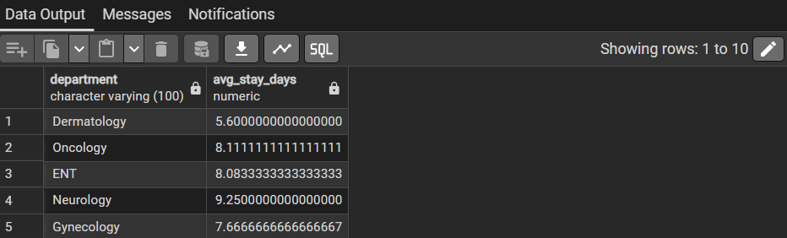

9. Identify the Department with the Lowest Number of Patients
●
Find the department with the least number of patients

Answer:
SELECT department,
SUM(patients_count) AS total_patients
FROM hospital_records
GROUP BY department
ORDER BY total_patients ASC
LIMIT 1;
Output:

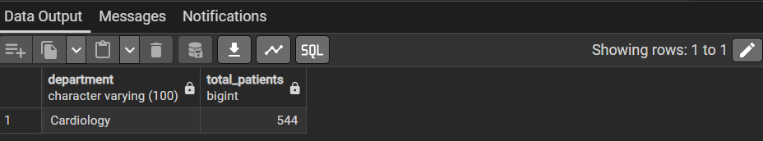

10. Monthly Medical Expenses Report
●
Group the data by month and calculate the total medical expenses for each month.

Answer:
SELECT TO_CHAR(admission_date, 'YYYY-MM') AS month,
SUM(medical_expenses) AS total_expenses
FROM hospital_records
GROUP BY month
ORDER BY month;
Output:

